Project Design Phase-II Technology Stack (Architecture & Stack)

Date | 7 November 2025
Team ID | NM2025TMID09077
Project Name | Laptop Request Catalog Item
Maximum Marks | 4 Marks

Technical Architecture:
The deliverable includes the architectural diagram and supporting details in Table 1 and Table 2.
This architecture represents how the Laptop Request Catalog Item in ServiceNow enables employees to request laptops efficiently through an automated workflow.
Example: Laptop Request Catalog Item
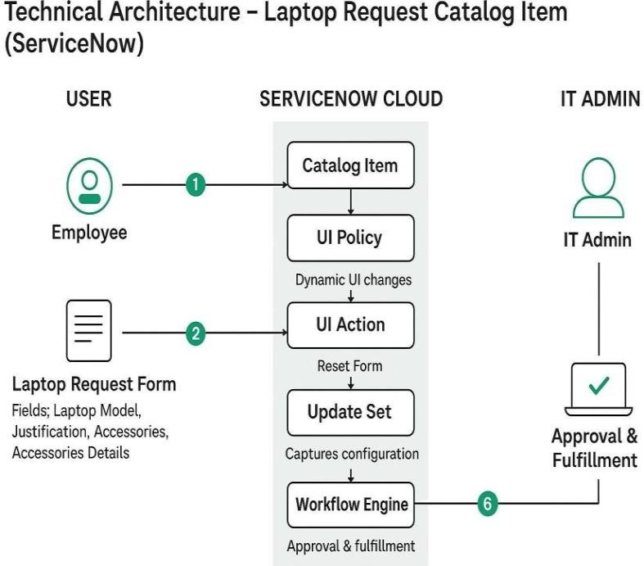
Guidelines:
- Include all ServiceNow processes (catalog item creation, UI policy, UI action, update set).
- Show infrastructure separation — Local Instance and Cloud Instance.
- Indicate external interfaces (email approvals, notifications).
- Highlight data storage in the ServiceNow database.
- Represent automation scripts for dynamic form behavior.
- Show deployment flow of update sets between instances.

S.No | Component | Description | Technology
1 | User Interface | Employees request laptops via  Service Catalog form. | ServiceNow Service Catalog UI
2 | Application Logic -  1 | Catalog item creation with  defined variables. | ServiceNow Catalog Item Form
3 | Application Logic -  2 | Dynamic behavior to show/hide  fields based on user input. | Catalog UI Policy
4 | Application Logic -  3 | “Reset Form” functionality  implemented using client script. | ServiceNow UI Action
5 | Database | Stores catalog item configurations and variable  values. | ServiceNow Tables
6 | Cloud Database | Data stored and managed  securely in ServiceNow cloud. | ServiceNow Cloud Database
7 | File Storage | Update set and configuration  stored in ServiceNow instance. | System Update Sets
8 | External API (Optional) | Integration for hardware asset inventory (if required). | REST API Integration
9 | Update Migration | Migrate update set across  instances. | XML Export/Import
10 | Infrastructure (Server/Cloud) | Entire system hosted and managed on ServiceNow SaaS. | ServiceNow Cloud (SaaS)

S.No Characteristics Description Technology

- Open-Source Frameworks
Not applicable, as ServiceNow is a proprietary low-code platform. –

- Security Implementations
Role-based access ensures only authorized users can create, approve, or manage laptop requests.
Role-Based Access Control (RBAC), ACLs

- Scalable Architecture Built on ServiceNow’s SaaS model, allowing easy scalability
across departments and instances.
- Availability Always accessible via the ServiceNow cloud, ensuring 24/7 uptime and redundancy.
- Performance Efficient performance through optimized catalog forms, client
scripts, and indexed data tables.
ServiceNow Cloud Architecture

Load-balanced ServiceNow Instances
GlideRecord, Service Catalog Optimization

